**Flight of the Model Rocket, Tristan Morse, Inquire Page # 2**

**Description of Observation**

While I was in 7th grade, I was in a design and engineering class and got to learn a little bit about model rockets. Since I was already really interested in rockets and topics that had to do with space, I naturally felt attracted to the idea of a model rocket. These are smaller scale, black-powder propelled rockets that usually come back to the ground by either falling with a non-ballistic trajectory, with a parachute, or by some other means. Since I have learned some more about physics and enjoy this topic, I want to figure out a calculation for a specific model rocket. If I were to have a Saturn V model rocket for example, as shown in *figure 1,* and launched it in a no wind environment, how high would it go?

**Visual**

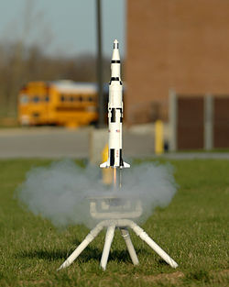

*Figure 1: Model rocket on launch pad (*<https://goo.gl/ZwnNNQ>*)*

**Physics Principles at Work**

A few physics principles at work in this observation are:

* Projectile Motion
* Newton’s 2nd and 3rd Laws
* Air Resistance

**Inquire**

What is the maximum height the model rocket reaches?

**Assumptions and Data Required**

Assumptions:

* All parts are in good condition
* There is no wind (with air resistance still present)
* All parts are assembled in a sturdy fashion
* The motor will work properly at its ideal potential
* The Launchpad is level
* The firing device works

Data Required

* Force Engine Exerts
* Velocity of the Rocket
* Mass of the Rocket
* Air resistance on Rocket
* Amount of Air Time